Relay symbols and device numbers;  selection from IEC 617-  and ANSI/IEEE C37.2-1991 | Означения на релета и номера на устройства, според ІЕС 617-  и ANSI/IEEE C37.2-1991
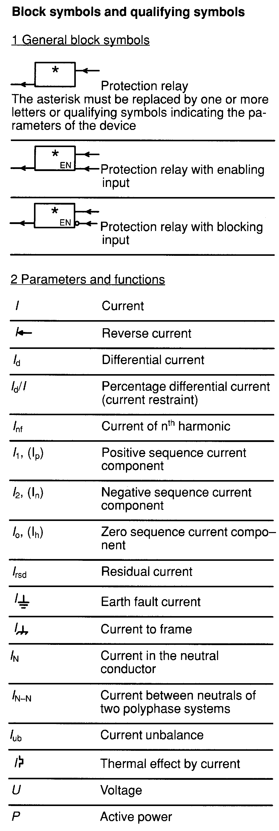

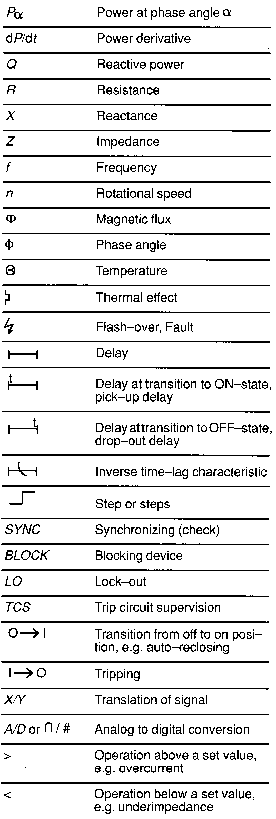

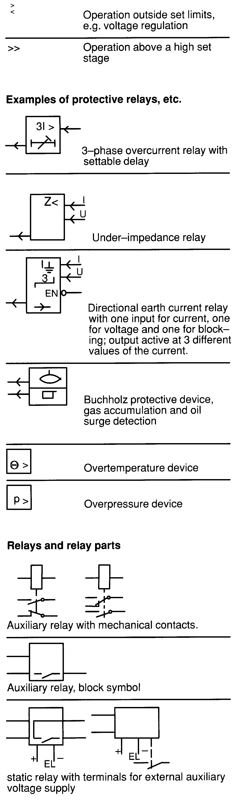

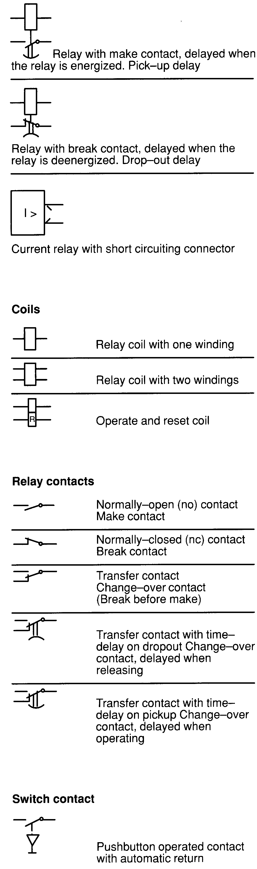

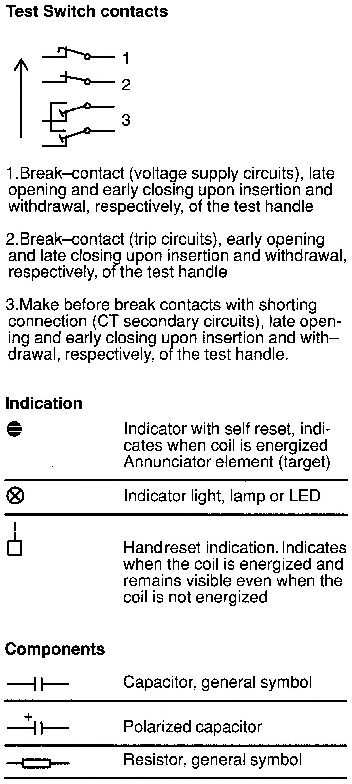

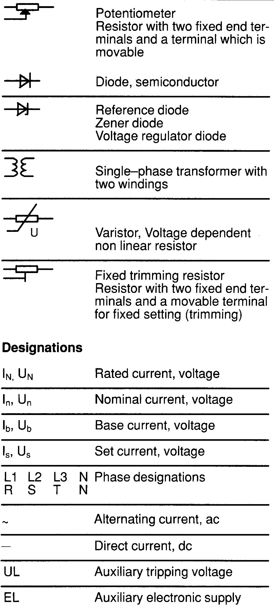

2. time-delay starting or closing relay is a device that functions to give a desired amount - of time delay before or after any point of operation in a switching sequence or protective relay system, except as specifically provided by device functions 48, 62, and 79.  3. checking or interlocking relay is a relay that operates in response to the position of a number of other devices (or to a number of predetermined conditions) in an equipment, to allow an operating sequence to proceed, or to stop, or to provide a check of the position of these devices or of these conditions for any purpose.  12. overspeed device is usually a direct-connected speed switch which functions on machine overspeed.  14. underspeed device is a device that functions when the speed of a machine falls below a predetermined value.  21. distance relay is a relay that functions when the circuit admittance, impedance, or reactance increases or decrease beyond a predetermined value.  25. synchronizing or synchronism-check device is a device that operates when two ac circuits are within the desired limits of frequency, phase angle, and voltage, to permit or to cause the paralleling of these two circuits.  26. apparatus thermal device is a device that functions when the temperature of the shunt field or the amortisseur winding of a machine, or that of a load limiting or load shifting resistor, or of a liquid or other medium exceeds a predetermined value; or if the temperature of the protected apparatus, such as a power rectifier, or of any medium decreases below a predetermined value.  27. undervoltage relay is a relay which operates when its input voltage is less than a predetermined value.  30. annunciator relay is a nonautomatically reset device that gives a number of separate visual indications upon the functioning of protective devices, and which may also be arranged to perform a lockout function.  32. directional power relay is a relay which operates on a predetermined value of power flow in a given direction, or upon reverse power such as that resulting from the motoring of a generator upon loss of its prime mover.  36. polarity or polarizing voltage device is a device that operates, or permits the operation of, another device on a predetermined polarity only, or verifies the presence of a polarizing voltage in an equipment.  37. undercurrent or underpower relay is a relay that functions when the current or power flow decreases below a predetermined value.  38. bearing protective device is a device that functions on excessive bearing temperature, or on other abnormal mechanical conditions associated with the bearing, such as undue wear, which may eventually result in excessive bearing temperature or failure. | 2. реле за време  14. Устройство, реагиращо при понижена честота на въртене (Защита при блокирал ротор на двигател)  21. дистанционно реле  27. минимално-напреженово реле  30. сигнално реле  32. посочно реле  37. минимално-токово или минимално-мощностно
39. mechanical condition monitor is a device that functions upon the occurrence of an abnormal mechanical condition (except that associated with bearings as covered under device function 38), such as excessive vibration, eccentricity, expansion, shock, tilting, or seal failure.  40. field relay is a relay that functions on a given or abnormally low value or failure of machine field current, or on an excessive value of the reactive component of armature current in an ac machine indicating abnormally low field excitation.  46. reverse-phase or phase-balance current relay is a relay that functions when the polyphase currents are of reverse-phase sequence, or when the polyphase currents are unbalanced or contain negative phase-sequence components above a given amount.  47. phase-sequence voltage relay is a relay that functions upon a predetermined value of polyphase voltage in the desired phase sequence.  48. incomplete sequence relay is a relay that generally returns the equipment to the normal, or off, position and locks it out if the normal starting, operating, or stopping sequence is not properly completed within a predetermined time. If the device is used for alarm purposes only, it should preferably be designated as 48A (alarm).  49. machine or transformer thermal relay is  a relay that functions when the temperature of a machine armature or other load-carrying winding or element of a machine or the temperature of a power rectifier or power transformer (including a power rectifier transformer) exceeds a predetermined value. | 46. реле за тока на обратна последователност или реле за баланса на токовете  47. реле за фазовия ред на напреженията  49. термично реле за двигатели или трансформатори

50. instantaneous overcurrent relay. A relay that functions instantaneously on an excessive value of current.  51. ac time overcurrent relay. A relay that functions when the ac input current exceeds a predetermined value, and in which the input current and operating time are inversely related through a substantial portion of the performance range.  52. ac circuit breaker is a device that is used to close and interrupt an ac power circuit under normal conditions or to interrupt this circuit under fault or emergency conditions.  55. power factor relay is a relay that operates when the power factor in an ac circuit rises above or falls below a predetermined value.  56. field application relay is a relay that automatically controls the application of the field excitation to an ac motor at some predetermined point in the slip cycle.  59. overvoltage relay is a relay which operates when its input voltage is more than a predetermined value.  60. voltage or current balance relay is a relay that operates on a given difference in voltage, or current input or output, of two circuits.  62. time-delay stopping or opening relay is  a time-delay relay that serves in conjunction with the device that initiates the shutdown, stopping, or opening operation in an automatic sequence or protective relay system. | 50. токово реле с мигновено действие. Реле, което функционира мигновено при превишаването на една определена големина на тока.  51. максималнотоково реле за променлив ток. Реле, което задейства, когато неговият входен променлив ток превиши една определена стойност и на което входният ток и времето на заработване са обратно зависими през една съществена част от обхвата на действие.  52. прекъсвач за променливо напрежение  55. реле за фактора на мощността  59. максимално-напреженово реле  60. балансно реле за токове или напрежения  62. реле за време

63. pressure switch is a switch which operates on given values, or on a given rate of change, of pressure.  64. ground detector relay is a relay that operates on failure of machine or other apparatus insulation to ground.  NOTE: This function is not applied to a device connected in the secondary circuit of current transformers in a normally grounded power system, where other device numbers with a suffix G or N should be used, that is, 51 N for an ac time overcurrent relay connected in the secondary neutral of the current transformers.  67. ac directional overcurrent relay is a relay that functions on a desired value of ac overcurrent flowing in a predetermined direction.  68. blocking relay. А relay that initiates a pilot signal for blocking of tripping on external faults in a transmission line or in other apparatus under predetermined conditions, or cooperates with other devices to block tripping or to block reclosing on an out-of-step condition or on power swings.  74. alarm relay is a relay other than an annunciator, as covered under device function 30, that is used to operate, or to operate in connection with, a visual or audible alarm.  76. dc overcurrent relay is a relay that functions when the current in a dc circuit exceeds a given value.  77. pulse transmitter is used to generate and transmit pulses over a telemetering or pilot-wire circuit to the remote indicating or receiving device.  78. phase-angle measuring or out-of-step protective relay is a relay that functions at a predetermined phase angle between two voltages or between two currents or between voltage and current.  79. ac reclosing relay is a relay that controls the automatic reclosing and locking out of an ac circuit interrupter.  80. flow switch is a switch which operates on given values, or on a given rate of change, or flow.  81. frequency relay is a relay that responds to the frequency of an electrical quantity, operating when the frequency or rate of change of frequency exceeds or is less than a predetermined value.  84. operating mechanism is the complete electrical mechanism or servomechanism, including the operating motor, solenoids, position switches, etc, for a tap changer, induction regulator, or any similar piece of apparatus which otherwise has no device function number.  85. carrier or pilot-wire receiver relay is a  relay that is operated or restrained by a signal used in connection with carrier-current or dc pilot-wire fault relaying.  86. lockout relay is a hand or electrically reset auxiliary relay that is operated upon the occurrence of abnormal conditions to maintain associated equipment or devices inoperative until it is reset. | 63. реле за налягане  67. посочна токова защита (променлив ток)  68. блокиращо реле  74. сигнално реле  76. токово реле за постоянен ток  79. АПВ  81. честотно реле  84. задвижване (за прекъсвачи и др.)
87. differential protective relay is a protective relay that functions on a percentage or phase angle or other quantitative difference of two currents or of some other electrical quantities.  90. regulating device is a device that functions to regulate a quantity, or quantities, such as voltage, current, power, speed, frequency, temperature, and load, at a certain value or between certain (generally close) limits for machines, tie lines, or other apparatus.  94. tripping or trip-free relay is a relay that functions to trip a circuit breaker, contactor, or equipment, or to permit immediate tripping by other devices; or to prevent immediate reclosure of a circuit interrupter if it should open automatically even though its closing circuit is maintained closed.  95-99. Used only for specific applications in individual installations where none of the assigned numbered functions from 1 to 94 are suitable. | 87. диференциално реле  90. регулатор (за напрежение и др.)  94. изключвателно реле (за прекъсвач и др.)
Suffix Letters
Suffix letters may be used with device function numbers for various purposes. They permit a manifold multiplication of available function designations for the large number and variety of devices used in the many types of equipment covered by this standard. They may also serve to denote individual or specific parts or auxiliary contacts of these devices or certain distinguishing features, characteristics, or conditions which describe the use of the device or its contacts in the equipment.

A Alarm or auxiliary power
B Bus, or battery, or blower
BL Block (valve)
BP Bypass
BT Bus tie
C Capacitor, or condenser, or compensator, or carrier current, or coil
CC Closing coil
F Feeder of field or filament or filter or fan
G Generator or ground¹⁾
H Heater or housing
L Line or logic
M Motor or metering
N Neutral¹⁾ or network
Sl Seal-in
TC Trip coil
X Auxiliary relay
Y Auxiliary relay
Z Auxiliary relay
¹⁾Suffix N is generally used in preference to G for devices connected in the secondary neutral of current transformers, or in the secondary of a current transformer whose primary winding is located in the neutral of a machine or power transformer, except in the case of transmission line relaying, where the suffix G is more commonly used for those relays that operate on ground faults.

Other Suffix Letters
A Accelerating or automatic
B Blocking or backup
C Close or cold
E Emergency or engaged
F Failure or forward
H Hot or high
HR Hand reset
HS High speed
L Left or local or low or lower or leading
M Manual
0 Open
OFF Off
ON On
P Polarizing
R Right or raise or reclosing or receiving or
remote or reverse
S Sending or swing
T Test or trip or trailing
TDC Time-delay closing
TDO Time-delay opening
U Up

All auxiliary contacts and position and limit switches for such devices and equipment as circuit breakers, contactors, valves and rheostats, and contacts of relays:
a-Contact that is open when the main device is in the standard reference position, commonly referred to as the nonoperated or deenergized position, and that closes when the device assumes the opposite position
b-Contact that is closed when the main device is in the standard reference position, commonly referred to as the nonoperated or deenergized position, and that opens when the device assumes the opposite position

The simple designation a or b is used in all cases where there is no need to adjust the contacts to change position at any particular point in the travel of the main device or where the part of the travel where the contacts change position is of no significance in the control or operating scheme.

